**GAS LEAKAGE DETECTION**

A

Minor Project (IS2170)

Report

Submitted in the partial fulfillment of the requirement for the award of

Bachelor of Technology

in

Computer Science and Engineering IoT & IS

By:

**ADITHYAN S**

**223911105**

Under the guidance of:

**Prof. ANUBHAV SHIVHARE**



April 2024

Department of Computer Science and Engineering IoT & IS

School of Computer and Communication Engineering

Manipal University Jaipur

VPO. Dehmi Kalan, Jaipur, Rajasthan, India – 303007

Department of Computer Science and Engineering IoT & IS

School of Computer and Communication Engineering, Manipal University Jaipur,

Dehmi Kalan, Jaipur, Rajasthan, India- 303007

**STUDENT DECLARATION**

*I hereby declare that this project* ***Gas Leakage Detection*** *is my own work and that, to the best of my knowledge and belief, it contains no material previously published or written by another person nor material which has been accepted for the award of any other degree or diploma of the University or other Institute, except where due acknowledgements has been made in the text.*

Place: Manipal University Jaipur

Date: 23rd April 2024

**Adithyan S**

229311105

B.Tech CSE(Iot & IS) 4th Semester

**ABSTRACT**

Gas leak detection systems are critical for ensuring safety in various environments, including residential, commercial, and industrial settings. This project presents a gas leak detection system designed to detect methane gas using an MQ-5 gas sensor and an ESP32 microcontroller. The system continuously monitors gas concentrations, triggering a notification when the concentration exceeds a predefined threshold. The notification is sent via the Pushbullet service, providing real-time alerts to users on their mobile devices or computers. The project's modular design, use of threshold-based alerting, and integration with Pushbullet distinguish it from traditional gas detection systems. By leveraging the ESP32's Wi-Fi capabilities, the system enables remote monitoring and notification, enhancing safety and convenience. Calibration of the sensor and consideration of safety regulations ensure the reliability and effectiveness of the gas leak detection system

**TABLE OF CONTENTS**

|  |  |  |
| --- | --- | --- |
| **Serial no.** | **Contents** | **Page no.** |
| 1. | Introduction | 1 |
| 2. | Components Used | 1 |
| 3. | Methodology | 2 |
| 4. | Results | 4 |
| 5. | Conclusion | 5 |
| 6. | Bibliography | 5 |

1. **INTRODUCTION**
   1. **Background**

Gas leak detection is a crucial aspect of safety in various industries and environments, including residential homes, commercial buildings, and industrial facilities. Methane, a highly flammable gas, poses significant risks if leaked into the atmosphere, including fire hazards and potential explosions. Therefore, implementing reliable gas leak detection systems is essential for mitigating these risks and ensuring the safety of occupants and assets.

**1.2 Objectives**

* Develop a Reliable Gas Detection System
* Implement Threshold-based Alerting
* Integrate with Pushbullet Service
* Verify Accuracy and Reliability
* Enhance Safety and Risk Management

1. **Components Used**
2. ESP32 Microcontroller
3. MQ-5 Gas Sensor
4. Pushbullet Service
5. Wi-Fi Network

**2.1 Hardware Setup**

* Collect all the necessary hardware components:
* ESP32 microcontroller board
* MQ-5 gas sensor
* Servo motor
* Jumper wires
* Breadboard
* Wi-Fi network for internet connectivity
* Wiring:
* Connect the VCC pin of the MQ-5 sensor to the 3.3V or 5V pin on the ESP32.
* Connect the GND pin of the MQ-5 sensor to the GND pin on the ESP32.
* Connect the AOUT pin of the MQ-5 sensor to an analog pin (e.g., pin 34) on the ESP32.
* Connect Servo Motor:
* Connect the signal wire of the servo motor to a PWM pin (e.g., pin 12) on the ESP32.
* Connect the VCC (power) and GND pins of the servo motor to the corresponding 3.3V or 5V and GND pins on the ESP32, respectively.
* Power Supply:
* Power the ESP32 board using a USB cable connected to a computer or a USB power adapter.
* Alternatively, use a battery pack to power the ESP32 for portable operation.

**3.METHODOLGY**

* Problem Understanding and Requirement Analysis
* Component Selection and Setup
* Wi-Fi Connection and Initialization
* Gas Detection and Threshold Monitoring
* Alerting Mechanism with Servo Motor
* Push Notification Handling
* Continuous Monitoring and Looping
* Testing and Debugging

**3.2 Software Implementation**

Initializes Wi-Fi connection using the provided SSID and password.

Reads analog values from the MQ-5 gas sensor connected to pin 34.

Compares the gas concentration value with the predefined threshold.

If a gas leak is detected, rotates the servo motor connected to pin 12 by 90 degrees and sends a push notification using the Pushbullet API.

Continuously loops to monitor gas levels and repeat the detection process.

**Code:**

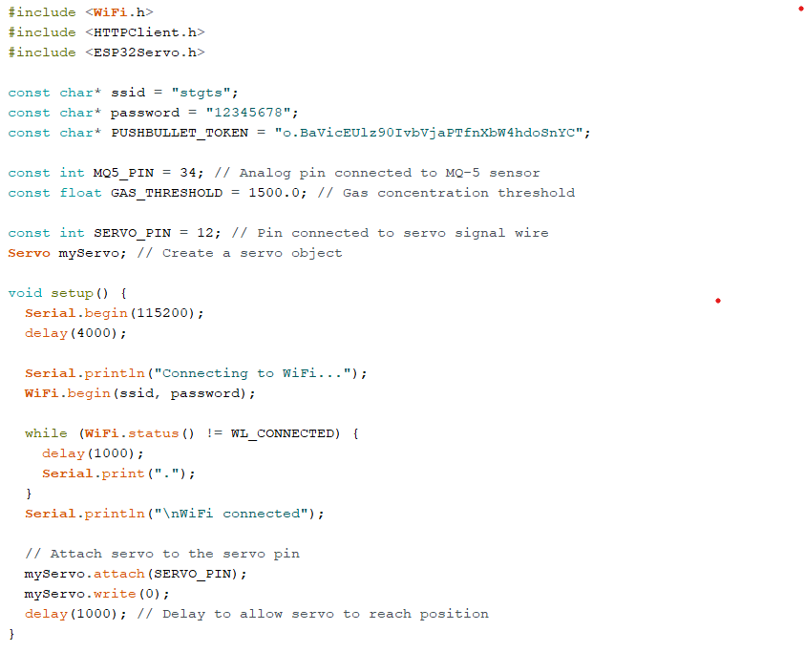

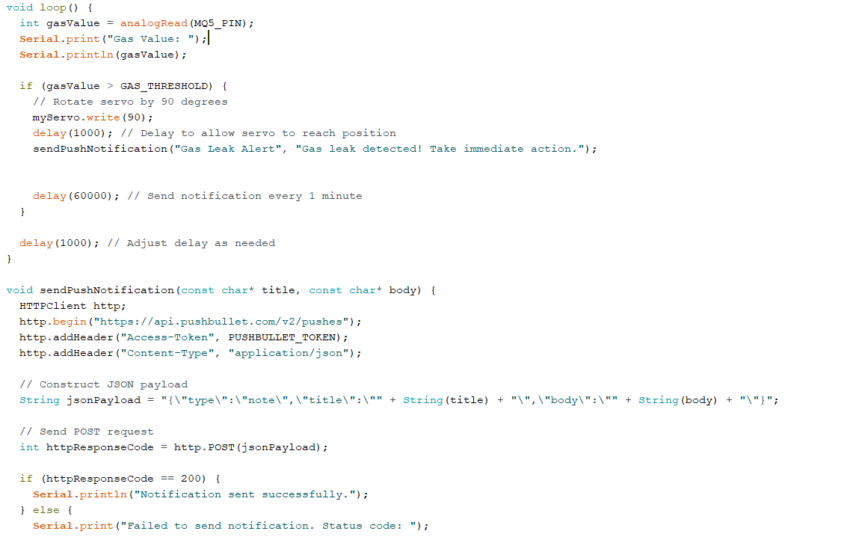

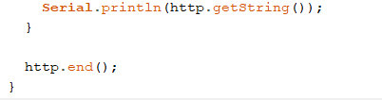

**RESULTS**

* Gas Leakage Detection: The bot accurately detect gas leaks by monitoring gas levels using the MQ-5 sensor. The detection threshold is set appropriately to trigger an alert when gas concentrations exceed a predefined threshold.
* Real-time Monitoring: The bot continuously monitors gas levels in real-time, providing immediate feedback on the presence of gas leaks. It is able to detect changes in gas concentrations quickly and respond accordingly.
* Alert Mechanism: Upon detecting a gas leak, the bot activates the alert mechanism by rotating the servo motor and sending a push notification via the Pushbullet API. The alert is timely and informative, prompting users to take immediate action to address the gas leak.

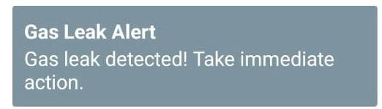

1. **CONCLUSION**

In conclusion, the development of the Smart Gas Leakage Detection Bot represents a significant step towards enhancing gas safety in residential, commercial, and industrial environments. By leveraging the capabilities of gas sensors, microcontrollers, and communication modules, the bot demonstrates its effectiveness in real-time monitoring and timely detection of gas leaks. With its alert mechanism and user-friendly interface, the bot empowers users to take immediate action in response to potential hazards, thus mitigating risks and safeguarding lives and property. Moving forward, continued refinement and deployment of the bot hold promise for further improving gas safety standards and reducing the incidence of gas-related accidents.

**BIBLIOGRAPHY**

1. McDonald, D., & Platt, R. (Year). Gas Detection Principles. Publisher.
2. Oxer, J., & Blemings, H. (Year). Practical Arduino: Cool Projects for Open Source Hardware. Publisher.
3. Monk, S. (Year). Raspberry Pi Cookbook: Software and Hardware Problems and Solutions. Publisher.
4. Nwatu, R. C., & Okeke, E. C. (Year). Design and Implementation of a Gas Leakage Monitoring and Control System.